**Introduction**

This document provides information about how to install, troubleshoot and maintain the Lancaster's Management software. In the first section, detailed instructions for installation are given as numbered steps. Finally, in the third section, miscellaneous information relevant to technical management and maintenance of the software is provided.

**Purpose**

In future, Lancaster's Restaurant may employ the services of IT professionals who are not members of the Code Crafters team (the developers of the Lancaster's Management software). The aforementioned individuals may be required to work, directly or indirectly, with the Lancaster's Management software. This document aims to provide information and guidance to assist in this work.

**Scope**

This document is intended for IT professionals. The information provided relates to installation, troubleshooting and maintenance - it does not relate to general usage of the software. For a user-friendly explanation of the various features of the software, please see the "User Guide".

**Section 1: Installation Guide**

-Go to https://www.oracle.com/java/technologies/downloads/ and download the appropriate JDK 22 for your operating system.

-Follow the installation instructions.

-Go to https://support.checkpoint.com/results/download/128410 and download the VPN.

-Follow the installation instructions.

-When the VPN is installed, the first time you connect it will ask you to create a new connection.

-When it asks for the server name, type: v501.city.ac.uk and connect.

-Follow the login instructions and the VPN will automatically connect.

-Download “LancasterRestaurant.jar” and run it.

**Section 2: Troubleshooting**

- If the app does not open, check to make sure you are connected to the VPN. You can check by opening the app:

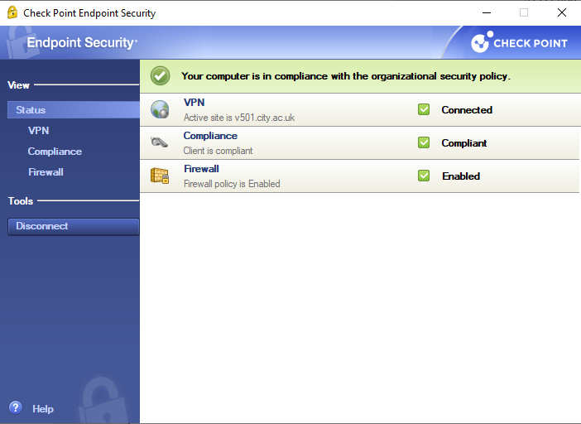

- If the app still does not open, check to make sure the correct version of Java is installed. To check on Windows, go to Settings -> Apps and search for Java. You should see Java Development Kit 22.0.1.

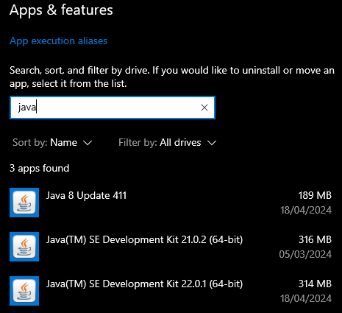

-If the app is still crashing, close it and try launching it again but through the terminal, on windows this can be done by going into the folder the “LancasterRestaurant.jar” and running this command:



**Section 3: Miscellaneous**

-Running “java LancasterRestaurant.jar” from the terminal will not work, it has to be run as shown above.